Fact Sheet: 2008 Olympic Village
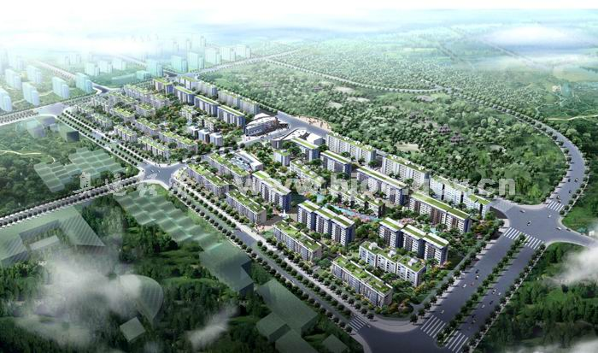

Project: Olympic Village to house athletes and officials at the 2008 Beijing Games. Project financed and built by a private developer. Residential units will be sold after the Games as high-end condos. The developer’s goals are a project that meets the strong environmental commitment of the Chinese government and the Games, while increasing the project’s market appeal at a cost that assures a reasonable profit margin.

The Chinese also have asked the U.S. Department of Energy to facilitate proposals from US companies related to a combined heat and power system for the Olympic Media Center. The system will provide heating, cooling and hot water for a 40,000 square-meter hotel at the site, as well low-pressure steam for hotel operations. Because DOE has few details about this system, the rest of this fact sheet describes only the Olympic Village.

Village Location: Northwest corner of the Olympic Park, adjacent to the Olympic Forest Park.

Size of site: 27.55 ha.

Population: 16,000 athletes and officials during Games.
1,822 families after Games.

Buildings: 42 residential buildings including 20 of nine stories and 22 of six stories. Typical apartments will have 3-4 bedrooms.

Appliances: None. Interior decoration and appliances will be the responsibility of the owners who purchase the units after the Games.

Floor area: Above ground: 413,250 m2, including 380,000 m2 for permanent residential buildings and 33,250 m2 for various public buildings that will be demolished after the Games. Below ground: 142,410 m2 garage space for 2,800 vehicles

Materials: Mostly concrete shear walls, with some frame-supported walls.

Traffic patterns: Cars will have limited access within the development after the Games. They will be restricted to an exterior ring around the development and to underground parking garages.

Green space: To help mitigate the urban heat island effect, 40.6% of the development will be green space. Building roofs will be planted with vegetation.

Energy: Wastewater heat pump with fan-coil unit terminals will provide heating, cooling, domestic hot water. Residential units all will be oriented for southern exposure and may have enclosed sunspaces.

Initial plans call for modest use of renewable energy technologies, including solar photovoltaics for outdoor lighting.

Lighting: Underground parking garages will feature T-8 flourescents with electronic ballasts and automatic controls.

Water: Wastewater will be discharged directly to a municipal treatment system. Rainwater will be stored in an underground well and used for irrigation, road cleaning, etc. Ample use of permeable surfacing will help manage storm water.

Solid Waste: Recycling containers will be positioned throughout the complex. Permanent residents will separate wastes at these containers, and wastes will be transported to municipal waste-management center.

The information in this fact sheets represents initial recommendations to the developer. All information is subject to change.

